Identification of bio-geophysical characteristics of Pahu watershed using GIS

**Suparjo1, Marjenah2, S Hardwinarto2  and M Sumaryono2**

1 Samarinda State Agriculture Polytechnic, Jl. Samratulangi Samarinda

2 Forestry Faculty of Mulawarman University, Jl.Ki Hajar Dewantara, Gunung Kelua Campus, Samarinda 75123, East Kalimantan, Indonesia.

Corresponding author email:suparjowd@gmail.com

**Abstract.** Pahu Sub Watershed is located at the upstream of Mahakam watershed system. Generally, upstream area is characterized by steep topography, and maintained as a conservation area. The flood frequency at Pahu Sub Watershed has been increasing year by year, with prolonged periods of flooding. This research aims to identify the bio-geophysical characteristics of Pahu Sub-watershed and to provide base-line information that can be used for preventing flood problem in the area. This study was conducted in Pahu Sub-watershed region, located at West-Kutai Districtusing. We used Geographic Information System. The Pahu sub-watershed covers an area of about 699 ha, and oval in shape. The region consists of areas with gradual slope. Soil type is dominated by organosol and podsolik. Main-stream length is about 163 km. The elevation differentiation between upper stream and down-stream is as much as 70 meters. Riverbed slope and average river width are 0.043% and 111.8 m, respectively. Majority of land cover is secondary forest and bush. The vegetation index of research area is 0.976. It means that 97.6% of the area is covered by vegetation. Average river-flow discharge of the last ten years is 471.94 m3/ second. The frequency and duration of flood are affected by high rainfall and flat topography. This research state that flood problem dominantly caused by bio-geophysical condition. But maintenance of Pahu sub watershed must be carefully planned.

1. **Introduction**

According to [2], the watershed is an area of land that is topographically confined by the backs of mountains holding and storing rainfall to flow into the main river and then through the sea. A watershed ecosystems include a variety of land use types, geomorphology, flora and fauna, physical buildings as well as various anthropogenic activities. The biotic and abiotic components [3] of the ecosystem interact one and each other and construct a complete unit.

Flooding is a severe problem that occur in most areas of Indonesia. Repeated flooding events happen during every rainy season. The frequency and the duration of the flooding events in a particular region vary depending on the characteristics of the region, e.g., land cover and geophysical characteristics. For instance, flooding often occurs in watershed areas, e.g., Sengatta [1]. Pahu sub watershed is one of the watershed areas that experience severe flooding. Also, the frequency and the duration of the flood events that occur in this area are increasing year by year. In such scenario, there are two important questions that need to be answered: (1) Why Pahu sub watershed experience frequent flooding events that continue for relatively longer periods? (2) What are the main factors that contribute for the problems?

In addition, Geographic Information System (GIS) has been often used to study watersheds, e.g., to assess the geo-hydrological characteristics of Vishav drainage basin and identify the ground water potential zones through geo-morphometric specs [5], to analyze and zoning of flood hazard of Mahakam River [6].

This research aims to identify the bio-geophysics that are related to flood problem of Pahu watershed region using GIS and to find out the possible causes of the flood incidents. We expect that the knowledge on the bio-geophysical characteristics would provide important information required for effective management of the Pahu sub watershed area and controlling flood problem.

1. **Research methods** 
   1. *Research Location.*

The research was carried out in Pahu Sub watershed that is located in West Kutai Regency, East Kalimantan province. According to [4] Pahu Sub watershed area covers 698,952 ha and divided into seven sub-sub watersheds, i.e., Idan, Nyuatan, Nyahing, Pahu, Perak, Lawa and Jelau.

* 1. *Research Procedure.*

The research procedure includes following stages:

* + 1. *Collecting Data*. The spatial data used in this study include the soil map, rainfall map, spatial area plan map of West Kutai Regency and land cover map provided by the Ministry of Environment and Forestry. Remaining thematic maps were prepared using Shuttle Radar Topography Mission (SRTM) data.
    2. *Georeferencing.* All Spatial data were georeferenced using the same reference system to accurately identify the actual ground conditions on the maps.
    3. *Developing topography map.* Topographic map was built from SRTM data using Global Mapper 17 software.
    4. *Demarcating sub watershed boundary.* Boundary of the sub watershed was developed from topographic maps using ArcView 33 series software. Particularly, the sub watershed boundary was built with abreast of topographic boundaries that correspond to the boundaries of the rain water stream exist in the area.
    5. *Digitizing soil map.* Soil map obtained from the RepproT resource was digitized and georeferenced using ArcView 33 series.
    6. *Digitizing Rainfall Map.* Rainfall map obtained from East Kalimantan Rainfall Map was also digitized.
    7. *Digitizing of land cover map.* Land cover maps obtained from the Environmental and Forestry Ministry are developed using Landsat and Copernicus imagery of 2016. Base on land cover map, it was calculated the Land Cover Index which implied ratio between total vegetation and total of study area. Land cover map was also digitized following the same method as soil and rainfall map digitization.
    8. *Measurement of stream width.* The stream width was measured on the remotely sensed image data. Positions of the measurement stations were placed at the upper stream, middle stream and lower stream, thus, all the parts of the main river in the watershed were measured.
    9. *Water flow measurement.* Water flow was measured directly at the field using a Lutron YK-2001PH water checker multi parameter instrument. The measurement was read directly on the instrument and recorded.

1. **Result**

Our GIS results revealed that Pahu sub watershed has an area of 698.952 hectares. The form of the basin is semicircle or oval with side lengthwise stretching from North to South. The main river splits symmetrically in the middle of the watershed and flows from West to East. The topography of the land is dominated by varying gradients of slope. Muara Pahu, Muara Lawa and Damai are the three sub districts that have flat-land. Based on the slope class map, total of the flat areas in the three sub districts are 38,554.4 ha. These districts had the highest risk of flooding. The slope condition of the study area can be seen in Figure 1.

The area comprised of organosol and podsolik soil. According to the Schmitd and Ferguson climate classification system, this region includes in B climate type of wet moisture with Q index value of 0.3115. Monthly precipitation for last ten years is described in Table 3. Pahu river is the main river with the length of 162.85 km. The width of the river measured at four stations were as shown in table 1. The average width of the river is about 111.8 meters. The elevation difference between the downstream and upstream is about 70 m. The river bottom slope is 0.043%.

The dominant land cover type is secondary forest and scrub. Based on the RTRWK map, the protection forest area is 20,822.4 ha, while based on a map of forest utilization directives broad the protection forest cover 32,328 hectares. There is a difference area of about 11,505.6 hectares. The digitized land cover map is shown in Figure 2. Land cover index was 0.97. The average speed of the flow discharge of the river is 0.998 m/second. Table 1 presents the flowing velocity measurements at four tributary.

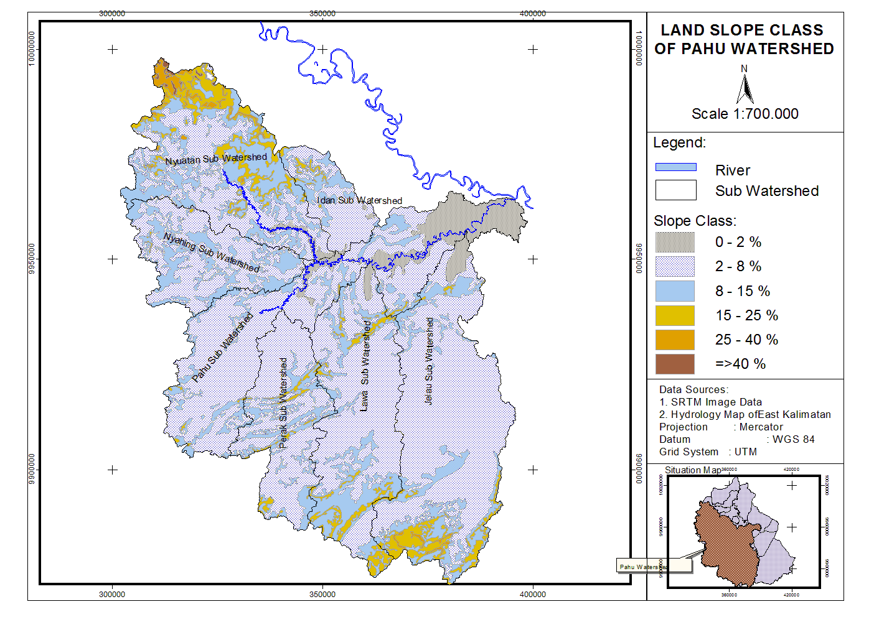

**Figure 1.** Slope map of the study area.

|  |  |  |  |  |  |
| --- | --- | --- | --- | --- | --- |
| **Table 1.** Stream width and flow measurement locations. | | | | | |
| NO | Location | Stream width (m) | Stream flow (m/second) | Coordinate | |
| 1 | Upper side Jelau River | 15 | 1.019 | 00°32'17.5" S | 115°54'43.3" E |
| 2 | Lower side Lawa River | 25 | 0.919 | 00°30'06.9" S | 115°44'57.3" E |
| 3 | Middle of Pahu River | 76 | 1.339 | 00°27'49.8" S | 115°45'43.6" E |
| 4 | Upper side Idan River | 10 | 0.715 | 00°22'26.6" S | 115°42'35.6" E |

|  |  |  |  |  |  |
| --- | --- | --- | --- | --- | --- |
| **Table 2.** Result of physical and chemical water measurements | | | | | |
| NO | River Name | TDS (mg/l) | pH | Temperature 0C | DO |
| 1 | Jelau | 44 | 6.50 | 26.45 | 1.25 |
| 2 | Lawa | 36 | 5.70 | 26.00 | 1.90 |
| 3 | Pahu | 24 | 5.49 | 27.70 | 2.45 |
| 4 | Idan | 23 | 5.76 | 26.00 | 1.80 |
|  | Mean: | 32 | 5.86 | 26.54 | 1.85 |

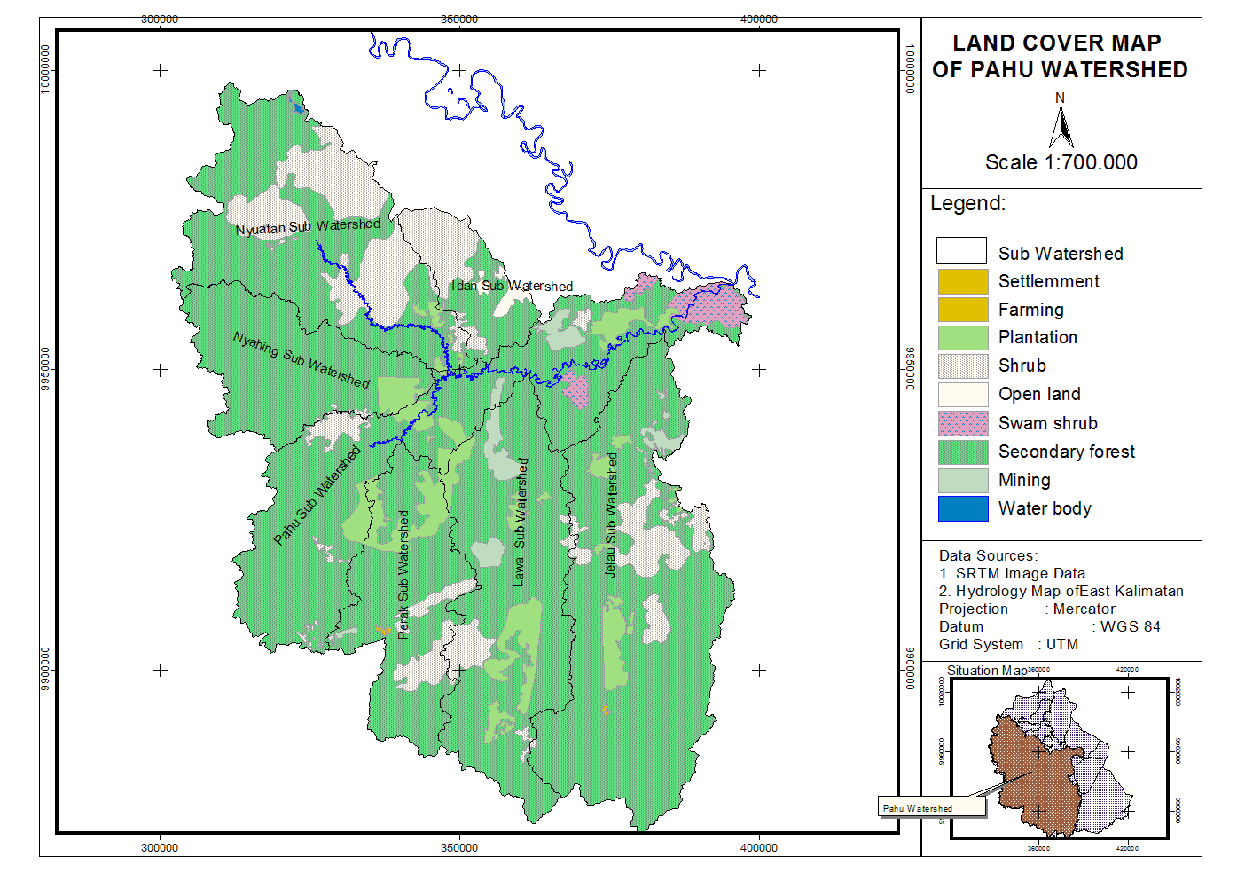  
**Note:** TDS and DO refers to total dissolved solids and dissolved oxygen, respectively.

**Figure 2.** Land cover map of the study area.

|  |  |  |  |  |  |  |  |  |  |  |  |  |
| --- | --- | --- | --- | --- | --- | --- | --- | --- | --- | --- | --- | --- |
| **Table 3.** Monthly precipitation at the study area for the last ten years (mm). | | | | | | | | | | | | |
| Year | Month | | | | | | | | | | | |
| Jan | Feb | March | April | May | June | July | August | Sept | Oct | Nov | Des |
| 2014 | 80.9 | 63.1 | 104.8 | 81.6 | 126.0 | 59.06 | 46.2 | 2.0 | 69.5 | 42.2 | 47.2 | 103.8 |
| 2013 | 451.9 | 300.7 | 299.1 | 314.7 | 27.5 | 78.4 | 85.7 | 69.8 | 72.4 | 85.5 | 275.7 | 506.4 |
| 2012 | 451.9 | 300.7 | 246.3 | 160.6 | 387.7 | 229.0 | 347.6 | 85.2 | 62.9 | 445 | 215.9 | 953.8 |
| 2011 | 231.4 | 182.9 | 188.8 | 166.7 | 125.0 | 29.2 | 2.0 | 21.3 | 178.4 | 408.1 | 582.4 | 631.6 |
| 2010 | 134.8 | 212.8 | 179.5 | 505.0 | 271.4 | 82.1 | 191.6 | 46.8 | 234.8 | 267.4 | 282.7 | 70.3 |
| 2009 | 357.3 | 277.4 | 398.2 | 250.0 | 179.2 | 10.3 | 63.7 | 57.3 | 124.9 | 187.3 | 396.3 | 244.3 |
| 2008 | 242.0 | 264.0 | 505.0 | 362.0 | 286.0 | 116.0 | 186.0 | 41.0 | 169.0 | 284.0 | 289.0 | 126.0 |
| 2007 | 483.0 | 176.0 | 343.0 | 475.0 | 299.0 | 76.0 | 188.0 | 114.0 | 35.0 | 196.0 | 106.0 | 218.0 |
| 2006 | 254.0 | 141.0 | 293.0 | 217.0 | 289.0 | 311.0 | 34.0 | 106.0 | 16.0 | 30.0 | 297.0 | 475.0 |
| 2005 | 303.0 | 135.0 | 342.0 | 164.0 | 171.0 | 142.0 | 146.0 | 170.0 | 30.0 | 313.0 | 231.0 | 438.0 |
| Total: | 2990 | 2054 | 2900 | 2697 | 2162 | 1134 | 1291 | 713 | 993 | 2259 | 2723 | 3767 |
| Avera: | 299.0 | 205.4 | 290.0 | 269.7 | 216.2 | 113.4 | 129.1 | 71.34 | 99.3 | 225.9 | 272.3 | 376.7 |

Explanation :

: dry month

: humid month

: wet month

1. **Discussion**

Although similar flood events were observed in Sengatta East Kutai [1], the characteristics of the two watersheds are different. For instance, Pahu watershed showed a topography dominated by gradual slopes and relatively lower river bottom slope (0.043%) which resulted in slower water surface flow. Further, the area of watershed determines the value of the river discharge flow. Particularly, in a wider catchment area that accommodates a large volume of water, there is a positive correlation between the discharge surface flow of a river and the size of the river body. Pahu sub watershed has a wide coverage area, thus, has large discharge in rainy season. In addition, the speed of the river surface flow depends on the slope of river bottom. For instance, [7] states that the speed of the stream is directly proportional to the slope of the river bottom. In this area the slope of the river bottom is 0.043% which is almost flat, and this further slowdown the surface flow. It should be noted that the speed of the surface flow of the Pahu river (Table 1) is lower than Mahakam River.

Based on geophysical characteristics, the area with flood risk is 38,554.4 ha. The dominant soil types in the area, i.e., organosol and podsolik, are easily eroded soil types [8]. The erosion in the watershed area led to sedimentation thus reduce water capacity of the river. Consequently, the low lying areas of the watershed would experience flooding during peak discharges of the river. Since, there is high possibility for flooding incidents during relatively higher rainfall, the highest risk of flood incidents would be in December (Table 3). Flooding could be anticipated in December by community around the risk area at Pahu sub watershed.

According to the regulation of the Minister of public works and Housing Number 28 year 2015 about river and Lake Boundary, a buffer zone of 100 m width should be the demarcated along the both sides of the river. This buffer zone should be a conservation area that is secured from any anthropogenic activity. Despite of having high land cover index (0.97), the present land cover types e.g., Palm plantation, forest plantation and shrub, have relatively lower capacity to prevent surface erosion. Thus land cover types that can prevent soil erosion should be encouraged in this area. Some mines and palm plantations exist along the main river (Figure 2). Such activities often result in soil erosion and sedimentation at the river. For instance, the total dissolve sediments measured in the part of the Jelau River reported the highest value (Table 2). This could be due to the commonly known fact that the upper of Jelau River there is associated with Gunung Bayan coal mining.

Overall, three sub districts (with an area of about 38,554.4 ha) could be identified as high flood risk areas based on the characteristics of bio-geophysics of Pahu sub watershed. In order to minimize flooding incidents, appropriate actions should be taken to prevent the massive land clearing events in the upstream area.

References

1. Koesnandar, R. and Hardwinarto S., 2014. Study On Land and Water Degradation of Sengata Watershed, East Kalimantan. *J. of Rimba Kalimantan* Forestry Faculty of Mulawarman University Vol.12 No. 1.
2. Asdak, C., 2007. Hidrologi dan Pengelolaan Daerah Aliran Sungai (cetakan keempat) Gadjah Mada University Press, Yogyakarta
3. Odum, E.P. 1972. Fundamentals of Ecology. University of San Carlos. USA. (Electronic Book).
4. Suparjo 2018. Health Evaluation of Pahu Sub Watershed In Relation To Flood Problem At West Kutai Regency. *J. of Biodiversity and Environmental Science (JBES)* Vol. **13**, No**.3**, p48-55, 2018
5. Hajam, R.A. ; Hamid, A.; Bhat, S., 2013. Application of Morphometric Analysis for Geo-Hydrological Studies Using Geo-Spatial Technology- A Case Study of Vishav Drainage Basin. *J. of Hydrology* Current Research 4:57. DOI. 10:4172/2157-7587.1000157.
6. Hardwinarto, S., 2008. Analysis and Zoning of Flood Hazard Level In 3 Sub Watershed of Mahakam River. Unpublished Research Report. West-Kutai.
7. Kambuaya, L., 2012. Hubungan Antara Kemiringan dan Kecepatan Aliran Air. <http://lorenskambuaya.blogspot.com/2012/12.>
8. Hardjowigeno, S. 2015. Ilmu Tanah. Akademika Pressindo, Jakarta.

**Acknowledgments**

The research was funded by the Directorate General of Research and Development, The Ministry of Research, Technology and Higher Education Republic of Indonesia through the scheme of doctoral dissertation grand year of 2018. The authors extend their gratitude to Samarinda State Polytechnic of Agriculture for all facilities to support this study. Thank for all who contributed for the research.